**Sub totals:**

A subtotal is a figure that shows the sum of similar sets of data but it does not indicate the final total. Subtotals are mainly used in sales, finance, and accounting reports

**Roll up:**

The GROUP BY statement in SQL is like the main character in a play. It gathers together rows with the same values and creates a summary row. Think of it as the star of queries that involve calculating things.

Now, imagine ROLLUP, CUBE, and GROUPING SETS as special features that make the main character even more exciting. They add extra rows that show subtotals and the overall total. It's like getting bonus scenes in the results.

If we want to figure out subtotals in a SQL query, we can use the ROLLUP feature of the GROUP BY statement. ROLLUP lets us create subtotal rows in a hierarchy based on the columns we choose. Plus, it throws in a grand total row at the end of the results. It's like getting a breakdown of the story and a big finale all in one.

**Example 1:**

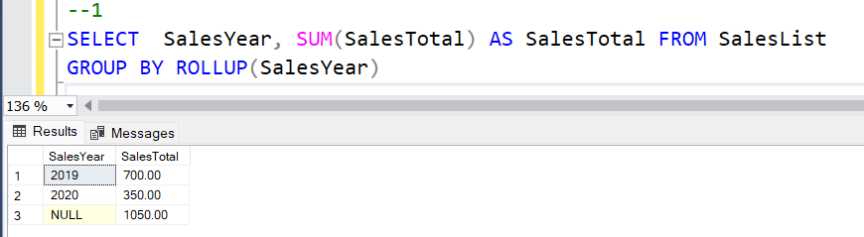

**Example 2:**

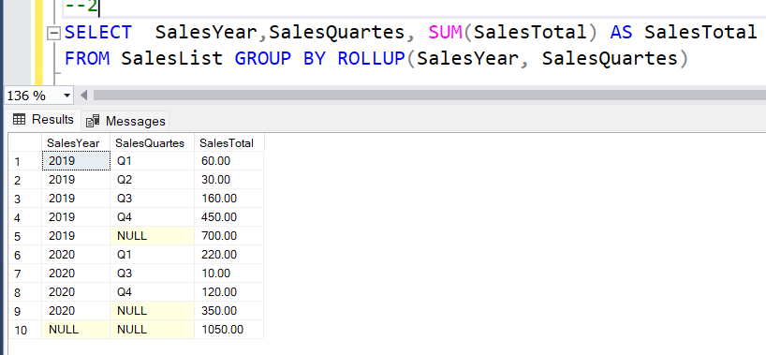

**Example 3:**

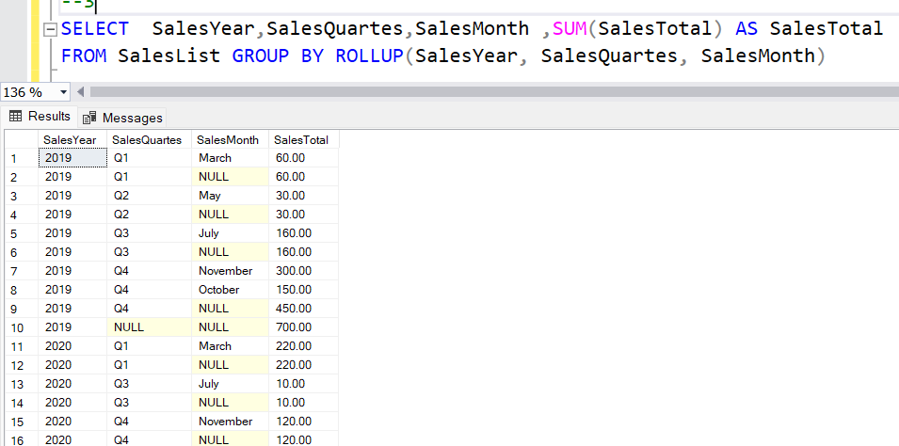

**Understanding grouping function:**

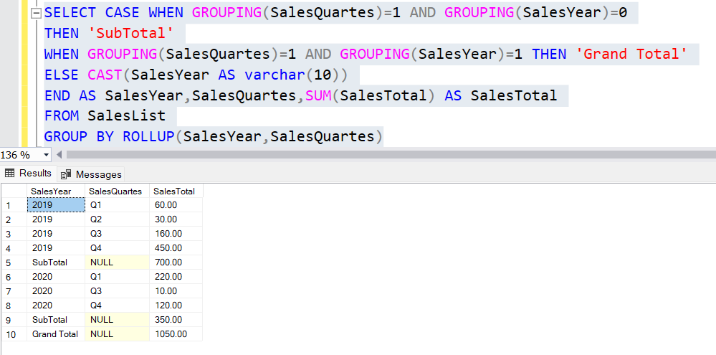

**Calculate subtotal in SQL query only for one column:**

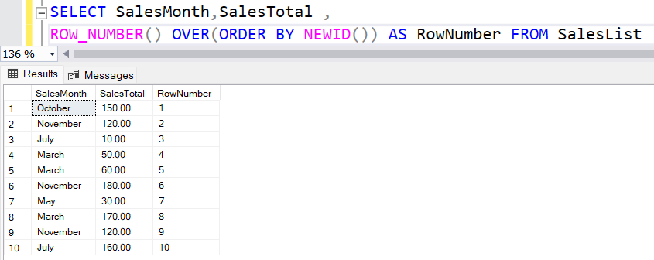

**Using GROUPING SET extension as an alternative method:**

